**Project Design Phase - I**  **Solution Architecture**

|  |  |
| --- | --- |
| Date | 19 October 2022 |
| Team Members | Rupadharshini T,Roshini B,  Pavya D,Nisha D |
| Project Name | Project – Smart Farmer-IoT Enabled Smart  Farming Application |
| Maximum Marks | 1. Marks |

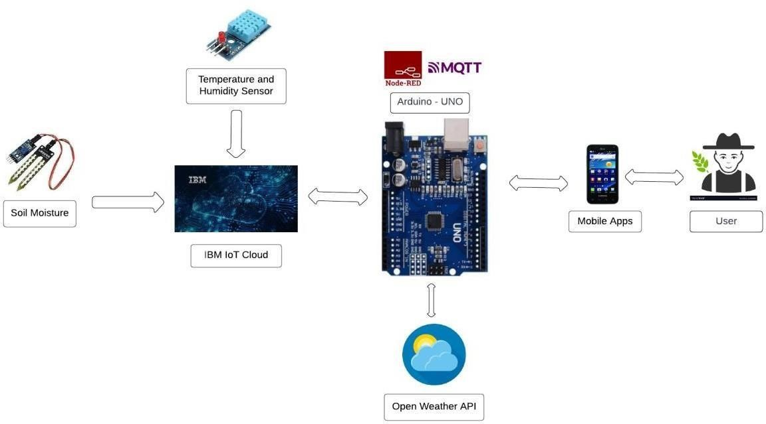

* Different sensors are used to measure the various soil characteristics (temperature, humidity, and soil moisture), and the results are saved in the IBM cloud.
* The data from sensors and weather data from weather API are processed using an Arduino UNO as a processing unit.
* Node-red is employed as a programming tool to connect the APIs, hardware, and software. It uses the MQTT protocol for communication.
* A mobile application that was created utilising the MIT app inventor gives the user access to all the collected data. Depending on the sensor results, the user might decide via an app whether to irrigate the crop or not. They are able to remotely control the motor switch by utilising the app.